AIM:

Aim is to program 8 puzzle problem using python program

PROGRAM:

import heapq

class PuzzleState:

def __init__(self, board, parent, move, depth, cost):

self.board = board

self.parent = parent

self.move = move

self.depth = depth

self.cost = cost

def __lt__(self, other):

return self.cost < other.cost

def __eq__(self, other):

return self.board == other.board

def print_solution(node):

path = []

while node is not None:

path.append(node.board)

node = node.parent

path.reverse()

for state in path:

for row in state:

print(" ".join(map(str, row)))

print()

def is_valid(x, y):

return 0 <= x < 3 and 0 <= y < 3

def get_neighbors(state):

neighbors = []

x, y = None, None

for i in range(3):

for j in range(3):

if state[i][j] == 0:

x, y = i, j

directions = [(1, 0), (-1, 0), (0, 1), (0, -1)]

for dx, dy in directions:

new_x, new_y = x + dx, y + dy

if is_valid(new_x, new_y):

neighbor = [row[:] for row in state]

neighbor[x][y], neighbor[new_x][new_y] = neighbor[new_x][new_y], neighbor[x][y]

neighbors.append(neighbor)

return neighbors

def heuristic(state, goal):

h = 0

for i in range(3):

for j in range(3):

if state[i][j] != goal[i][j]:

h += 1

return h

def solve_puzzle(initial_state, goal_state):

open_set = []

closed_set = set()

start_node = PuzzleState(initial_state, None, None, 0, 0)

heapq.heappush(open_set, start_node)

while open_set:

current_node = heapq.heappop(open_set)

if current_node.board == goal_state:

print("Solution found!")

print_solution(current_node)

return

closed_set.add(tuple(map(tuple, current_node.board)))

neighbors = get_neighbors(current_node.board)

for neighbor in neighbors:

if tuple(map(tuple, neighbor)) not in closed_set:

move = current_node.move

if move is not None:

move += 1

new_cost = current_node.cost + 1

new_depth = current_node.depth + 1

new_node = PuzzleState(neighbor, current_node, move, new_depth, new_cost + heuristic(neighbor, goal_state))

heapq.heappush(open_set, new_node)

print("No solution found.")

if __name__ == "__main__":

initial_state = [

[1, 2, 3],

[8, 0, 4],

[7, 6, 5]

]

goal_state = [

[1, 2, 3],

[8, 0, 4],

[7, 6, 5]

]

solve_puzzle(initial_state, goal_state)

INPUT:

Solution found !

OUTPUT:

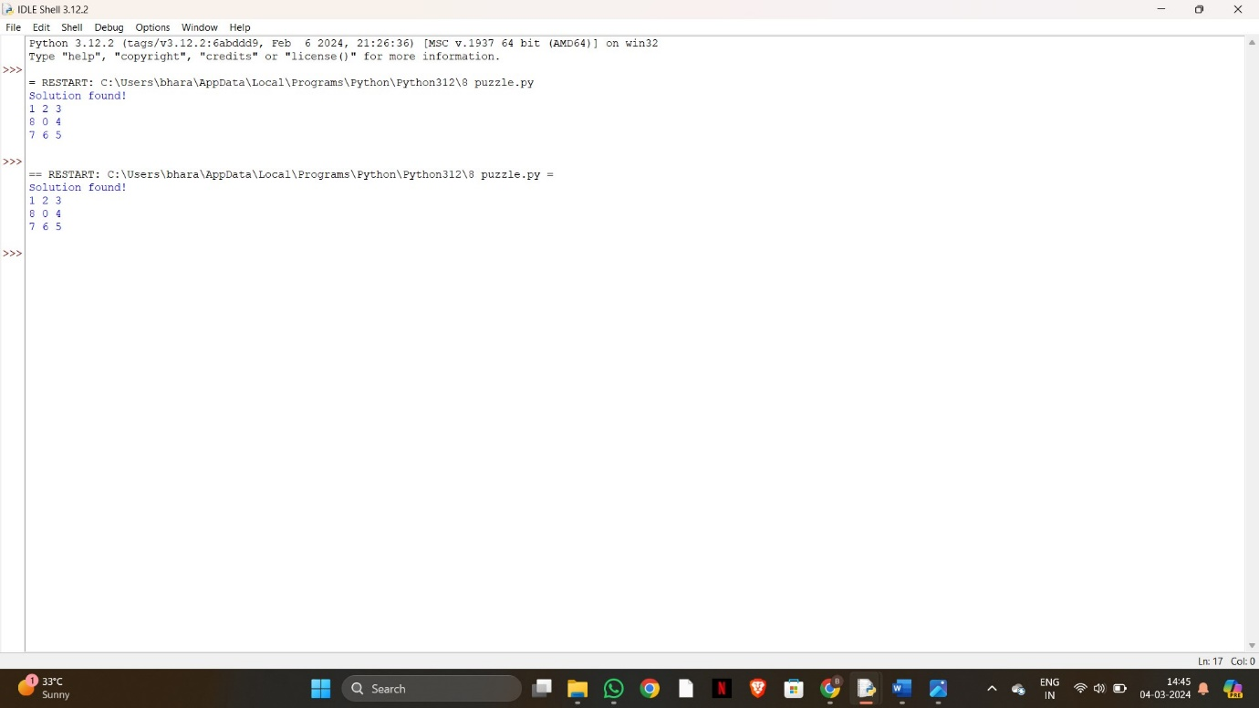

RESULT:

Thus the implementating to 8 puzzle is successfully completed.